Software requirement and specifications (SRS)
Introduction:
An Intrusion Detection System (IDS) is used to watch malicious activities over the network. It can sort the unfamiliar records as normal or attack class. First monitoring is done, and then they order the network traffic into malicious class or regular class. It acts as an alarm system that reports when an illegal activity is detected. The exactness of the IDS depends upon detection rate. If the performance is high for the IDS, then the correctness of detection is also high. Some of the intrusion detection systems are marketed with the ability to stop attacks before they are successful. We are even seeing new systems marketed as intrusion detection systems. Intrusion detection systems have existed for a long time. They are used to shield an association from attack. It is a relative concept that tries to identify a hacker when penetration is attempted. Ideally, such a system will only alarm when a successful attack is made. Intrusion detection system is not a perfect solution to all attack types. A good security program or security tools cannot be replaced by an IDS. The genuine users who may try to access the information for their pleasure cannot be identified with the help of IDS. The goals of IDS provide the requirements for the IDS policy. The potential goals include the following:
- IDS detect attacks.
- IDS traces user activity from point of entry to
- IDS generate alerts when required.
- Detect errors in system configuration.
- Provides security of the system without the need of non – expert staff.
- IDS can detect when the system is under attack.
- Provides evidences for attack.
Existing system:
Network Intrusion Detection System (NIDS) and Host Intrusion Detection System (HIDS). Network Intrusion Detection system is a mechanism that is used within the network to identify the malicious event. The network traffic is monitored in the network that is in the sub- net. If an attack is observed it matches the traffic with the known attack list. Then an alert is passed to the administrator. NIDS is installed in router to identify the passage of network traffic. HIDS runs on an individual system. The functions of two IDSs are the same. HIDS also monitors the unauthorized activity. It takes a short review of the existing files in the system. Then it matches it with the old system files. If it finds an intrusion or changes in the system, then an alert is passed to the administrator. The intrusion can be detected as if a file is modified or deleted, then it means malicious activity is reported.
Design:
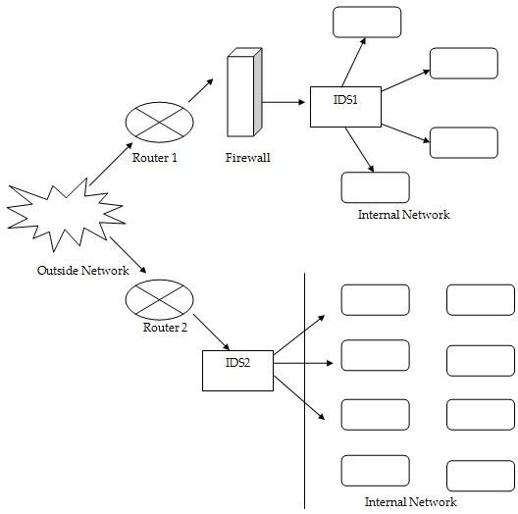

Disadvantages:
- NIDS can only alarm if the traffic matches the predefined rules.
- NIDS cannot determine if the attack was successful.
- NIDS cannot examine the traffic that is encrypted.
- Switched networks require special configurations so that the NIDS can monitor all the traffic.
Proposed system:
Previously, in existing system NIDS and HIDS are implemented for identifying existing intrusions based on the id. If there is any new dynamic intrusion occurs NIDS and HIDS they didn’t detect the intrusions. So this is the major drawback in existing system.
Support vector machine is a technique that has been emerged for the analysis of data for the classification process. The support vector machine is also known as support vector networks. The SVM uses a set of training data where each one has been labeled into one of two categories. The training data set builds a model and the new unknown data would be categorized into the proper group. There will be a linear separation between the data that has to be classified. With the help of this line the data can be easily separated with more accuracy. In this technique, two categories are available; we can either classify the data to one class or to the other class depending upon the behavior of the new data. In addition to linear classification, they can perform non linear classification also. In non linear classification, data are not labeled so supervised learning is not possible. In such a context, unsupervised learning approach is implemented, which attempts to cluster the data with similar behavior.

Advantages:
- In proposed system, we are implementing algorithm called support vector machine (SVM).
- This algorithm detects the existing intrusions and also dynamic intrusions.
- So, SVM provide high security to our system without losing our valuable data.
- SVM can generate correct and strong classification results.
- SVM are flexible and powerful classification algorithm.
- It can produce best results even if the training data are few in number.
Software Requirements:
- OS : Windows
- Python IDE : python 2.7.x and above
: Pycharm IDE
- setup tools and pip to be installed for 3.6.x and above

Hardware Requirements:
- RAM : 4GB and Higher
- Processor : Intel i3 and above
- Hard Disk : 500GB: Minimum

FEASIBILITY STUDY:
Preliminary investigation examine project feasibility, the likelihood the system will be useful to the organization. The main objective of the feasibility study is to test the Technical, Operational and Economical feasibility for adding new modules and debugging old running system. All system is feasible if they are unlimited resources and infinite time. There are aspects in the feasibility study portion of the preliminary investigation:
- Technical Feasibility
- Economical Feasibility
- Operation Feasibility

Technical Feasibility:
In the feasibility study first step is that the organization or company has to decide that what technologies are suitable to develop by considering existing system.
Here in this application used the technologies like Visual Studio 2015 and SqlServer 2014. These are free software that would be downloaded from web.
Visual Studio 2013 –it is tool or technology.

Determining Economic Feasibility:

Assessing the economic feasibility of an implementation by performing a cost/benefit analysis, which as its name suggests compares the full/real costs of the application to its full/real financial benefits. The alternatives should be evaluated on the basis of their contribution to net cash flow, the amount by which the benefits exceed the costs, because the primary objective of all investments is to improve overall organizational performance.
Type | Potential Costs | Potential Benefits
Quantitative | - Fully-burdened cost of labor (salary + benefits)  - Support costs for the application  - Expected operational costs  - Training costs for users to learn the application  - Training costs to train developers in new/updated technologies | - Reduced operating costs  - Reduced personnel costs from a reduction in staff  - Increased revenue from additional sales of your organizations products/services
Qualitative | - Increased employee dissatisfaction from fear of change | - Improved decisions as the result of access to accurate and timely information  - Raising of existing, or introduction of a new, barrier to entry within your industry to keep competition out of your market  - Positive public perception that your organization is an innovator
The table includes both qualitative factors, costs or benefits that are subjective in nature, and quantitative factors, costs or benefits for which monetary values can easily be identified. I will discuss the need to take both kinds of factors into account when performing a cost/benefit analysis.
Operational Feasibility
Not only must an application make economic and technical sense, it must also make operational sense.
Operations Issues | Support Issues
- What tools are needed to support operations?  - What skills will operators need to be trained in?  - What processes need to be created and/or updated?  - What documentation does operations need? | - What documentation will users be given?  - What training will users be given?  - How will change requests be managed?
Very often you will need to improve the existing operations, maintenance, and support infrastructure to support the operation of the new application that you intend to develop. To determine what the impact will be you will need to understand both the current operations and support infrastructure of your organization and the operations and support characteristics of your new application. To operate this application END-TO-END VMS. The user no need to require any technical knowledge that we are used to develop this project is Asp.net ,C#.net. That the application providing rich user interface by user can do the operation in flexible manner.
Functional requirement:
Outputs from computer systems are required primarily to communicate the results of processing to users. They are also used to pro vide a permanent copy of the results for later consultation. The various types of outputs in general are:
- External Outputs, whose destination is outside the organization,.
- Internal Outputs whose destination is within organization and they are the
- User’s main interface with the computer.
- Operational outputs whose use is purely within the computer department.
- Interface outputs, which involve the user in communicating directly.
- Understanding user’s preferences, expertise level and his business requirements through a friendly questionnaire.
- Input data can be in four different forms - Relational DB, text files, .xls and xml files. For testing and demo you can choose data from any domain. User-B can provide business data as input.

Non functional requirements:
- Secure access of confidential data (user’s details). SSL can be used.
- 24 X 7 availability.
- Better component design to get better performance at peak time
- Flexible service based architecture will be highly desirable for future extension

